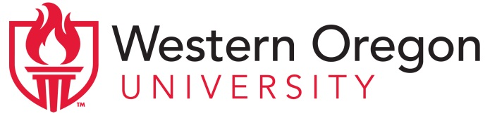
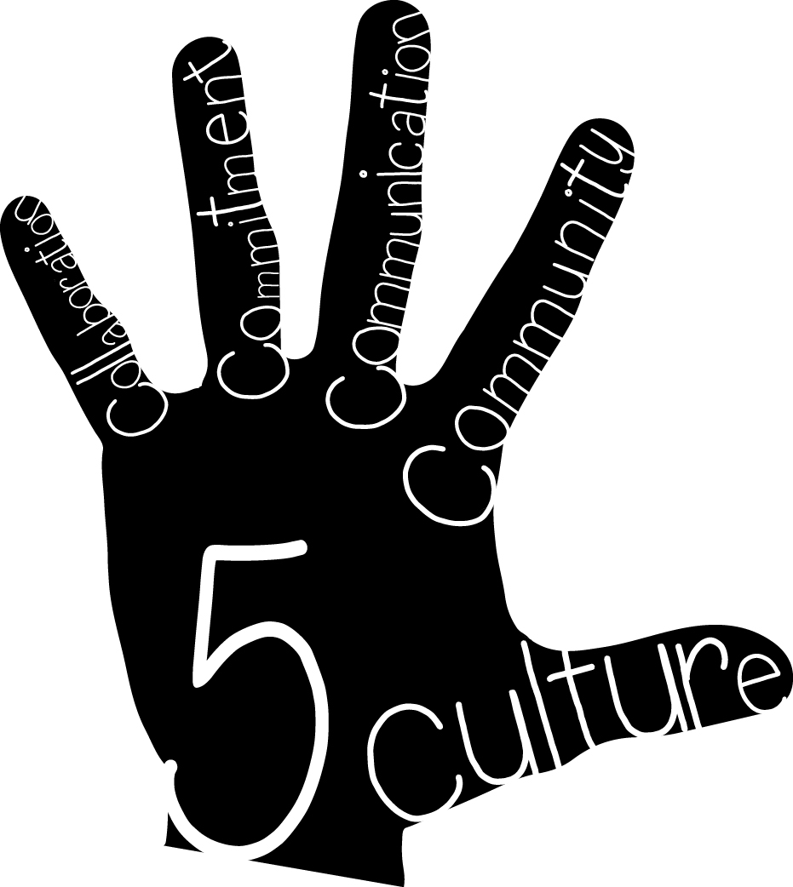 | Project High Five: Culture, Collaboration, Commitment, Communication, and Community  Advisory Council Meeting Agenda  March 11, 2015-- 4:00-5:30pm  Central High School, Room 138

Members of the Advisory Council:

Western Oregon University  Maria Dantas-Whitney, Co-director  Chloe Hughes, Co-director  Sue Thompson, Director of Clinical Practice and Licensure  Marie LeJeune, Community Liaison  Anne Foltz, ELD Content Specialist  Cheri McLain, Clinical Coordinator  Marcus Wenzel, Clinical Coordinator  Christina Reagle, External Evaluator | Central School District  Buzz Brazeau, Superintendent  Jason Clark, CHS Assistant Principal  Steve Tillery, IES Principal  Laura Zinck, ELD Coordinator  Holly Sims, IES teacher  Kelli Fink, TMS teacher  Mike Jennings, CHS teacher  Katie Babcock, UG Teacher Candidate  Mason Grine, MAT Teacher Candidate | Community Members  Odilon Campos, OCDC  Morris Johnson, ECFB

Topics for Discussion:

- Welcome & introductions

- Updates on grant activities
- Co-teaching (Chloe and Sue):
  - Follow-up workshops on Feb 12 and April 22
  - Videotaping at MES and IES; plans for videotaping in other buildings
  - Invitation: Consortium on April 30
- Contextualized ELD (Maria and Anne):
  - Focused ELD workshops on Jan 12 and Jan 26
  - Videotaping at ACES; plans for videotaping at MES and IES
- Service Learning Projects (Marie):
  - Workshops on culturally-relevant pedagogy in seminars

- Upcoming community events (Marie):
- Author Monica Brown:
  - April 9 evening event in Werner Center, Pacific Room
  - Elementary school visits on April 10
- Kindergarten Round-up on April 11 (10am-1pm at Henry Hill District Office)

- Future sustainability (Chloe and Sue):
  - Lessons learned from PDS conference
  - Ideas for sustaining the partnership after the grant ends

