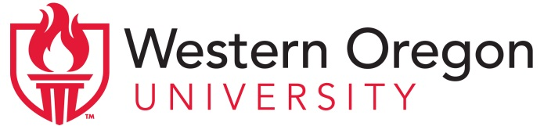
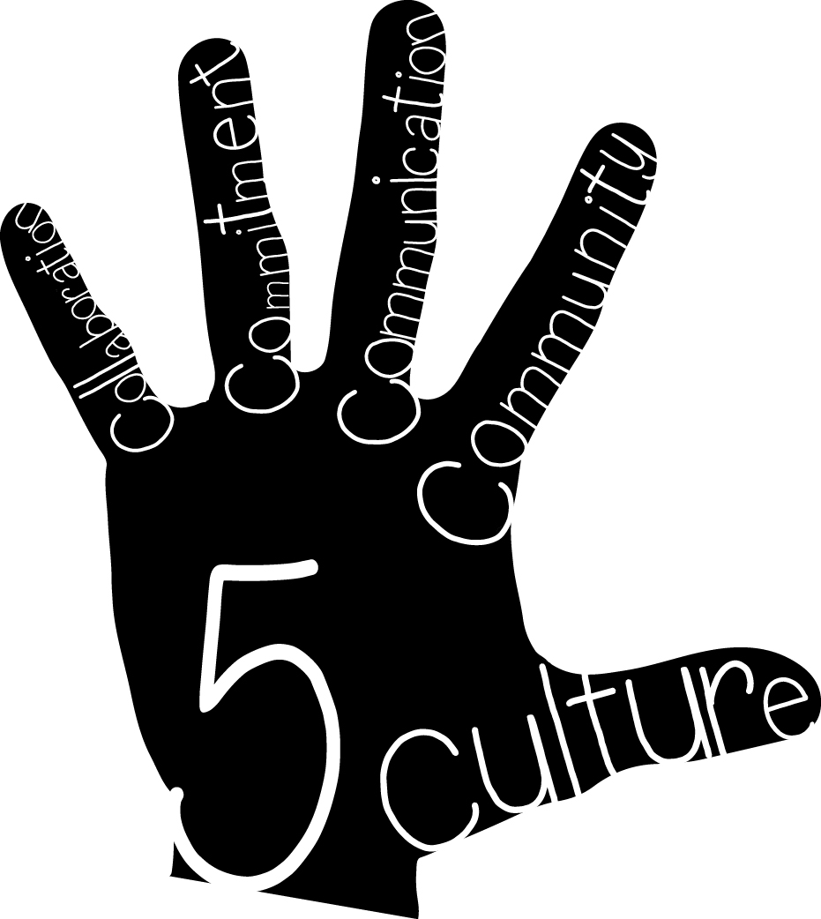 | Project High Five: Culture, Collaboration, Commitment, Communication, and Community  Advisory Council Meeting Agenda  May 13 , 2015-- 4:00-5:30pm  Central High School, Room 138

Members of the Advisory Council:

Western Oregon University  Maria Dantas-Whitney, Co-director  Chloe Hughes, Co-director  Sue Thompson, Director of Clinical Practice and Licensure  Marie LeJeune, Community Liaison  Anne Foltz, ELD Content Specialist  Cheri McLain, Clinical Coordinator  Marcus Wenzel, Clinical Coordinator  Christina Reagle, External Evaluator | Central School District  Buzz Brazeau, Superintendent  Jason Clark, CHS Assistant Principal  Steve Tillery, IES Principal  Laura Zinck, ELD Coordinator  Holly Sims, IES teacher  Kelli Fink, TMS teacher  Mike Jennings, CHS teacher  Katie Babcock, UG Teacher Candidate  Mason Grine, MAT Teacher Candidate | Community Members  Odilon Campos, OCDC  Morris Johnson, ECFB

Topics for Discussion:

- Welcome & introductions

- Updates on grant activities
- Co-teaching (Chloe):
  - Update on activities; sharing of video of Mike Thissell, Mason Grine, and Stacey Roberts
- Contextualized ELD (Maria and Anne):
  - Update on activities; sharing of video of Jessica Padilla
  - Community Events and Service Learning Projects (Marie):
    - Author Monica Brown
    - Kindergarten Round-up
    - Invitation for presentations of service learning projects on June 8
  - Summary of comments from last two Advisory Council meetings (Christina)
- Materials for secondary teachers – orders need to be placed asap
- Future sustainability (everyone):
  - Ideas for sustaining the partnership after the grant ends
  - Ideas for future activities if grant funds become available again

