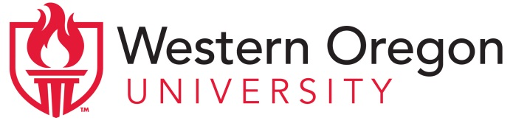
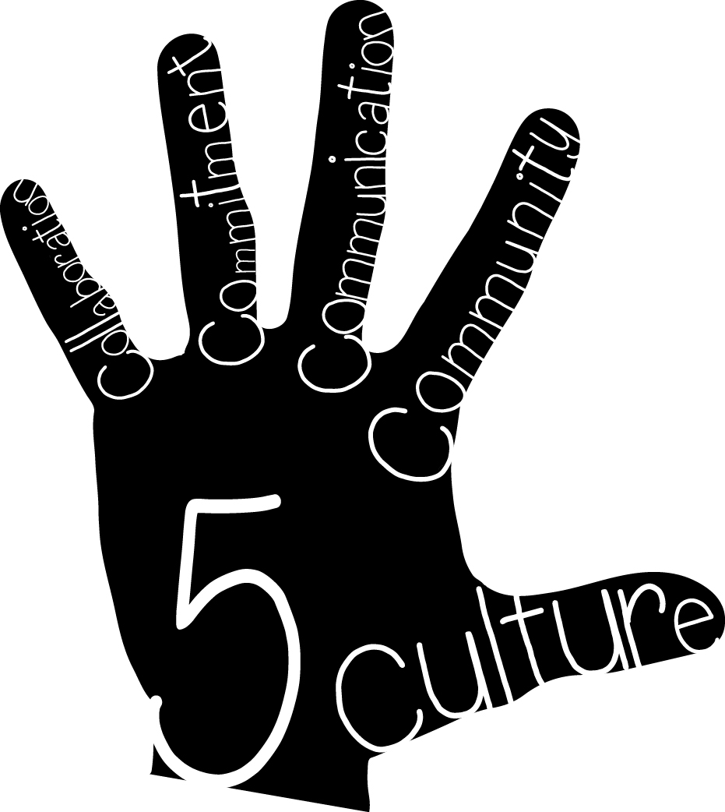 | Project High Five: Culture, Collaboration, Commitment, Communication, and Community  Advisory Council Meeting Agenda  November 12, 2014 -- 4:00-5:30pm  Central High School, Room 138

Members of the Advisory Council:

Western Oregon University  Maria Dantas-Whitney, Co-director  Chloe Hughes, Co-director  Sue Thompson, Director of Clinical Practice and Licensure  Marie LeJeune, Community Liaison  Anne Foltz, ELD Content Specialist  Cheri McLain, Clinical Coordinator  Marcus Wenzel, Clinical Coordinator  Christina Reagle, External Evaluator | Central School District  Buzz Brazeau, Superintendent  Jason Clark, CHS Assistant Principal  Steve Tillery, IES Principal  Laura Zinck, ELD Coordinator  Holly Sims, IES teacher  Kelli Fink, TMS teacher  Mike Jennings, CHS teacher  Katie Babcock, UG Teacher Candidate  Mason Grine, MAT Teacher Candidate | Community Members  Odilon Campos, OCDC  Morris Johnson, ECFB

Topics for Discussion:

- Welcome & introductions

- Overview of grant goals and activities: Three threads
- Co-teaching (Chloe and Sue)
- Contextualized ELD (Maria and Anne)
- Service Learning & Community Connections (Marie)
- Evaluation (Christina)

- Update on activities so far:
Co-teaching PD:  - Elementary (Clinical Teachers): June 2014  - Middle/High (Clinical Teachers): August 2014  - Everyone (Teacher Candidates and Clinical Teachers): November 2014 | Contextualized ELD PD:  - Elementary: August 2014  - Middle/High: August 2014  - Everyone: August 2014  - New teachers (Additional PD provided by Laura and Kira): September 2014 | Service Learning & Community Connections  - Intro. to Service learning Projects: November 2014  - Meetings with Odi and Morris (needs assessment)

- Plans for future activities:
Co-teaching:
Winter PD -- February
Spring PD – date TBA
“HW” activities (e.g., family conferences & phone calls)

Contextualized ELD:
“Focused PD” instead of “coaching” – planning in Fall; PD in Winter and Spring
Work with teacher dyads in each school who can inspire others and demonstrate exemplary practices

Sustainability:
Videos of lessons and planning sessions
Case studies
Interviews with Teacher Candidates and Clinical Teachers
Documenting impact on student learning
Other ideas

Service Learning & Community Connections:
Community needs (Odi and Morris)

Planning of events:

Fall (December 5): How can we encourage participation of school and community partners?

Winter:

Spring:

