Service Learning Project
Information Packet
Western Oregon University

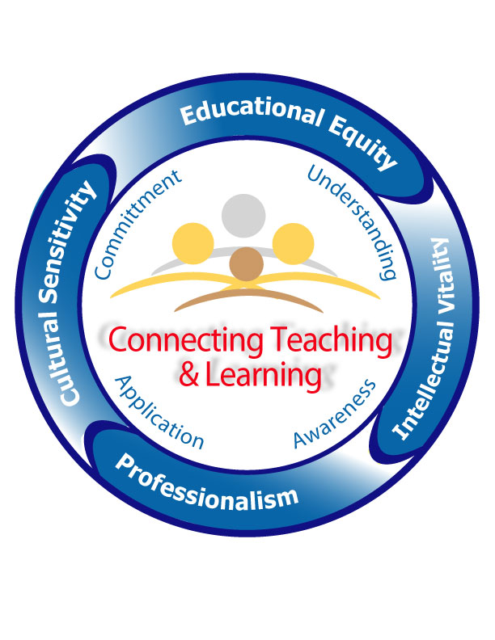

Term III Service Learning Project Overview

Service learning is…
A teaching and learning approach that integrates community service with academic study to enrich learning, teach civic responsibility, and strengthen communities. Ideally, service learning projects will reflect your knowledge about culturally relevant and responsive practices that use cultural context as a bridge to teaching and learning, and involve the members of the classroom community, school, district, and larger setting to meet actual needs and draw on available resources.

What you will need to do…
Either individually, with a partner or small group, or as a part of a larger community within your school site, cohort, or within the Project High Five Grant, you will develop and design a project that:
- Integrates community service with academic study
- Enriches the learning experience (for you and your students)
- Engages in civic responsibility, culturally responsive practices, and authentic work that draws on community resources.
- Strengthens the community (and ideally provides opportunities for such work to continue)

Who will be involved?
This is a project you can choose to complete either as an individual or on a team with other teacher candidates. You might develop an entirely new project or work on a service project that exists within your school site or the larger community. The project should enrich your learning and also ideally will involve your students in a meaningful way that enriches their learning.

Thinking about how you will choose a project…
Through assignments such as your community mapping, creation of your setting for your TWS, and other assignments that ask you to deeply study the culture of your individual students, classroom, and larger community, you will have learned about both the needs of your community and the resources available. Your mentor/clinical teacher, other teachers in the community, administrators, cohort leaders, and other individuals in the community can all be valuable sources of information and ideas for approaching your service learning project.

Reflecting on your project…
During the final student teaching seminar you will share your project with your peers, likely in a gallery walk setting. This means that you will need to prepare a visual to share with your peers about your project (ex: poster board, slide show, etc.) You will also write a brief reflection paper on the knowledge gained from taking part in service learning, which you will turn in to your Term III seminar leader. (Guidelines for this paper are included in this packet.)

What You Will Create/Turn In

On your last seminar day you will be sharing your service learning projects with your cohort and others from the WOU community. There are two pieces of the project to bring.

- First, you will bring a display that tells about your project. This could be in a poster format, involve artifacts, or be created digitally. (See assignment sheet at back of packet for ideas of what to include.) Each project will be briefly described (1 minute) to the large group. There will be a “gallery walk” or “poster session” following where others will view your projects and you will be able to answer questions, chat, and discuss your project in a “meet and greet” format. (Note: If your project was completed with other classmates, only one project display is necessary for the group.)

2. Each of you will turn in a short, 2-3 page reflection paper about your service learning project. Papers are individual reflections and a separate, unique paper should be created even if you worked with others on your service learning project. Your paper will be turned in to your cohort leader on the day of the final seminar. (Again, see assignment sheet at back of packet for ideas of what to include/how to format your paper.)

Assignment Sheet Instructions:
Project Display

Project Display

- Create an informative overview of your project that is easy to read, organized, and professionally presented.
- Your project can be on a trifold poster board, in a digital format that you are prepared to display, or in another format that makes sense for your project.
- Include the following information:
  - A brief description of the purpose of the project
  - Who was involved? WOU students? Public school students? Other teachers? Staff? Community members?
  - What actions/steps were involved?
  - The impact/results of the project.
  - Consider including artifacts such as: photos, drawings, sketches, charts/tables, physical artifacts, samples of student work, etc. (Note: you do not need all of the above; consider what makes sense for your project.)
- Be prepared to speak about your project, giving a brief overview of its impact and your learning. Plan to answer questions.
- Proofread all materials carefully.
- Only one project presentation is necessary if you completed your service learning project as part of a small group or partnership.

Assignment Sheet Instructions:
Reflection Paper

Reflection Paper

- Your paper should be approximately 2-3 pages in length, typed, double spaced. If you use cite any materials, include a reference sheet in addition to your 2-3 page paper and cite in APA style.
- Your paper will have two main sections: 1) an overview/review of the project and 2) your reflection on completing the service learning project.

- Section 1: Overview of Project

Include the following information:
- Title of Project
- Site of project and short description of setting
- Participants and how they were involved
- Overview/description that explains the importance of this project and how it responds to the needs and/or funds of knowledge in the community. (Consider students, families, the classroom, school, district, etc.)
- Link to important outcomes such as state/national objectives, school learning goals, INTASC standards, etc. as appropriate

- Section 2: Personal Reflection

Your reflection will be unique and individual, but here are some prompts that might help you think through what you would like to include in your reflection. These are just a jumping off point to get you started, you are not required to answer all of these and might also choose to include other details not listed here:

    - How successful do you think the service learning project was?
    - Have your beliefs about teaching and learning changed as a result of this experience?
    - How did you integrate culturally relevant practices into your project and what impact did that have on you as a teacher and learner?
    - What impact do you believe this project had on students and their families? Why?
    - What impact did this project have on the larger school, district, or community?
    - What resources did you learn about that will be useful to you as a professional educator?
    - How were you able to use collaboration effectively in this project?
    - How will this experience affect your future teaching practice?
    - What were the strengths of the project? The weaknesses?
    - How did your project incorporate the “Standards of Quality” for Service Learning (See Appendix)

Optional Planning Sheet/Brainstorming Sheet
(Also consult the “Standards of Quality” on the next page)

- What are some needs and funds of knowledge I am aware of in my setting/site?

- Who might I talk to about needs, resources, and developing my project at my setting/site?

- How can I involve my students in the project in a way that links to important content learning and standards?

- What steps/timeline will I need to follow?

- What data will I gather to document the effect of my project?
Facts/Research About Service Learning

Oregon is a member of the Alliance for Service Learning in Education Reform. This group has developed the following list of standards:

Standards of Quality for School-Based and Community-Based Service Learning

- Effective service learning efforts strengthen service and academic learning.
- Model service-learning provides concrete opportunities for youth to learn new skills, to think critically, and to test new roles in an environment that encourages risk taking and rewards competence.
- Preparation and refection are essential elements in service learning.
- Youths’ efforts are recognized by those served, including their peers, the school, and the community.
- Youth are involved in the planning.
- The service students perform makes a meaningful contribution to the community.
- Effective service-learning integrates systematic formative and summative evaluation.
- Service-learning connects the school or sponsoring organization and its community in new and positive ways.
- Service learning is understood and supported as an integral element in the life of a school or sponsoring organization and its community.
- Skilled adult guidance and supervision are essential to the success of service-learning.
- Preservice training, orientation, and staff development that include the philosophy and methodology of service learning best ensure that the program quality and continuity are maintained.

More details and resources can be found at: http://tncampuscompact.org/files/qsbc.pdf

Other Useful Resources on
Culturally Responsive Teaching
and Service Learning

www.solv.org: SOLVE, focuses on environmental service learning and volunteer opportunities in Oregon

www.nylc.org: National Youth Leadership Council, dedicated to growing young leaders, supporting educators, and advancing the field of service learning.

gsn.nylc.org/clearinghouse: Provides an expansive online library of lesson plans, documents, and other resources related to service learning.

www.rethinkingschools.org: Dedicated to social justice and culturally responsive teaching practices, Rethinking Schools provides publications, forums, lesson ideas, and networking.

nameorg.org: The National Association for Multicultural Education site provides resources, contacts, and information regarding advocating for social justice and equity.

www.tolerance.org: Provides lesson ideas, film clips, documents, and short reading pieces on issues related to culture, justice, and equity.

A few places to find authentic, culturally rich, children’s/young adult literature (fiction and nonfiction):
Notable Books for a Global Society: http://clrsig.org/

Lee & Low Books: https://www.leeandlow.com/

Jane Addams Children’s Book Award: http://www.janeaddamspeace.org/jacba/

Skipping Stones Honors Awards: http://www.skippingstones.org/honors_98.htm

SCORING SHEET FOR WRITTEN COMPONENT OF PAPER/PROJECT
 | 3 | 2 | 1 | 0
Paper Section I: Overview of Project | The paper addresses all required components, with concrete examples. | The paper addresses most of the components and/or gives vague examples in spots. | The paper addresses some of the components. | The paper does not follow the assignment guidelines.
Paper Section II: Personal Reflection | The reflection includes multiple examples and thoroughly connects the service project to student and teacher learning. | The reflection includes some examples but does not thoroughly connect the work to student and teacher learning. | The reflection is limited and/or does not reflect an understanding of culturally relevant practices in service learning. | The paper does not follow the assignment guidelines/is missing a personal reflection.
Paper Formatting  /Style | The paper is edited, professional, and free of grammatical and spelling errors. References are cited correctly (APA). | The paper is edited, professional, and has few grammatical and/or spelling errors. References are included. | The paper does not appear sufficiently edited and has significant spelling, grammar, style, or reference errors. | The paper appears unedited and poorly constructed.
Project Display | The project display is: easy to read, organized, and professionally presented and includes all required information. | The project display is generally easy to read, organized, and professionally presented but may be missing some required information. | The project display is unclear, disorganized, and/or not carefully edited. Key information may be missing. | The project does not follow the required format or is unfinished.
Project  Presentation | Presenter(s) are able to speak clearly and convincingly about the project’s goals & outcomes. | Presenter(s) speak clearly about the project’s goals & outcomes. | Presenter(s) struggle with describing the project’s goals & outcomes. | Presenter(s) are absent or unprepared.
Project Sources/  Citations | References and citations are included to support the project’s rationale, goals, & outcomes and are APA formatted. | Some references and citations are included to support the project. APA formatting is attempted. | References/citations are limited or incomplete (or incorrect). | No references/citations are included to support the project
Formatting: Refer to your packet for more detailed prompts and expectations for the paper and presentation. Papers should be 2-3 pages in length, double spaced, APA formatting. Your cohort leader will give you time frames for your oral presentation.

